Why and How Your Body Makes Millions of Red Blood Cells Every Minute

Your red blood cells are highly specialized to carry oxygen from your lungs to the rest of your body. Each red blood cell is packed full of hemoglobin, the molecule that carries oxygen. A red
blood cell has:  - millions of molecules of hemoglobin  - no nucleus, ribosomes, mitochondria, or other organelles.  1a. Describe the characteristics of red blood cells that allow them to carry maximum oxygen to the other cells in the body. | 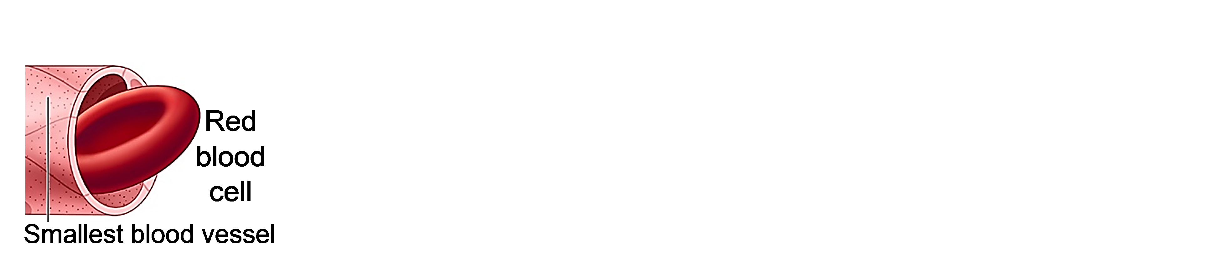

1b. An average red blood cell only lasts about four months before it becomes too damaged to survive. In contrast, many cells in your body live for years. How could the specialized characteristics of red blood cells contribute to their shorter lifespan?

Your body has trillions of red blood cells. Since each red blood cell only lasts for a few months, roughly 2 million of your red blood cells die every second. So, your body makes roughly
2 million replacement red blood cells per second!

The process of making new red blood cells starts with blood stem cells in your bone marrow.
- Blood stem cells have normal organelles, including a nucleus, ribosomes and mitochondria. Blood stem cells do not contain hemoglobin.
- When a blood stem cell divides, one of the daughter cells becomes a replacement blood stem cell. The other daughter cell divides repeatedly to produce cells that develop into red blood cells or several other types of blood cells.
2. Your body has fewer than 200,000 blood stem cells, but your body makes millions of red blood cells every minute. Why don’t you run out of blood stem cells?  3. Describe two basic steps that you think are needed to convert blood stem cells to red blood cells. (Hint: Think about the differences between blood stem cells and red blood cells.) | 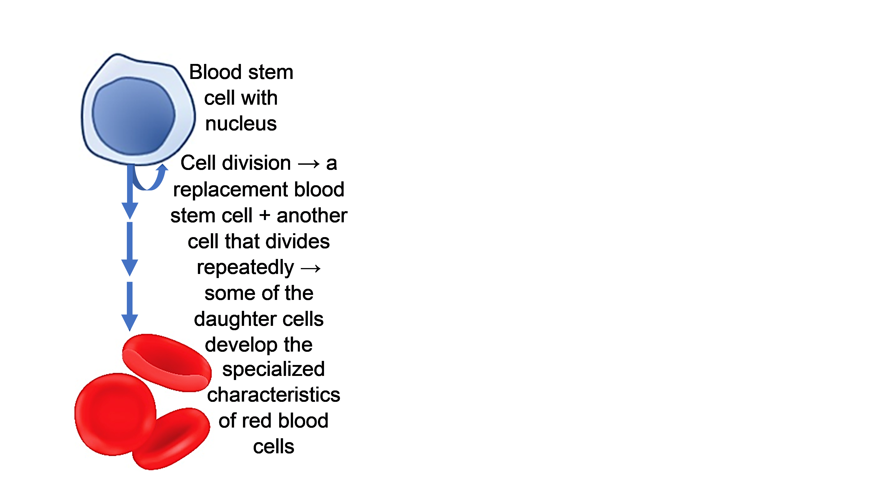

For an overview of the process that converts stem cells to specialized cells like red blood cells, watch the video, Cell Differentiation (https://www.pearson.com/channels/biology/asset/f8063efc/cell-differentiation-genetics-biology-fuseschool).

4a. What is cell differentiation?

4b. When does cell differentiation occur? only in embryos ___ only in children ___
only in adults ___ in embryos, children and adults ___

4c. Explain why cell differentiation is needed at the stage(s) when it occurs.

We will analyze a small part of the complex process of cell differentiation that produces red blood cells. Since red blood cells are full of hemoglobin, we will focus mainly on the processes that begin the production of hemoglobin proteins.

5. As background, we should review how a gene in the DNA provides the instructions for making a protein. Fill in each blank with mRNA, proteins, ribosomes, or RNA polymerase.  During transcription of a gene in the DNA, the enzyme,  ________________________, makes ________.  During translation of the mRNA molecules,  __________________ make ________________. | 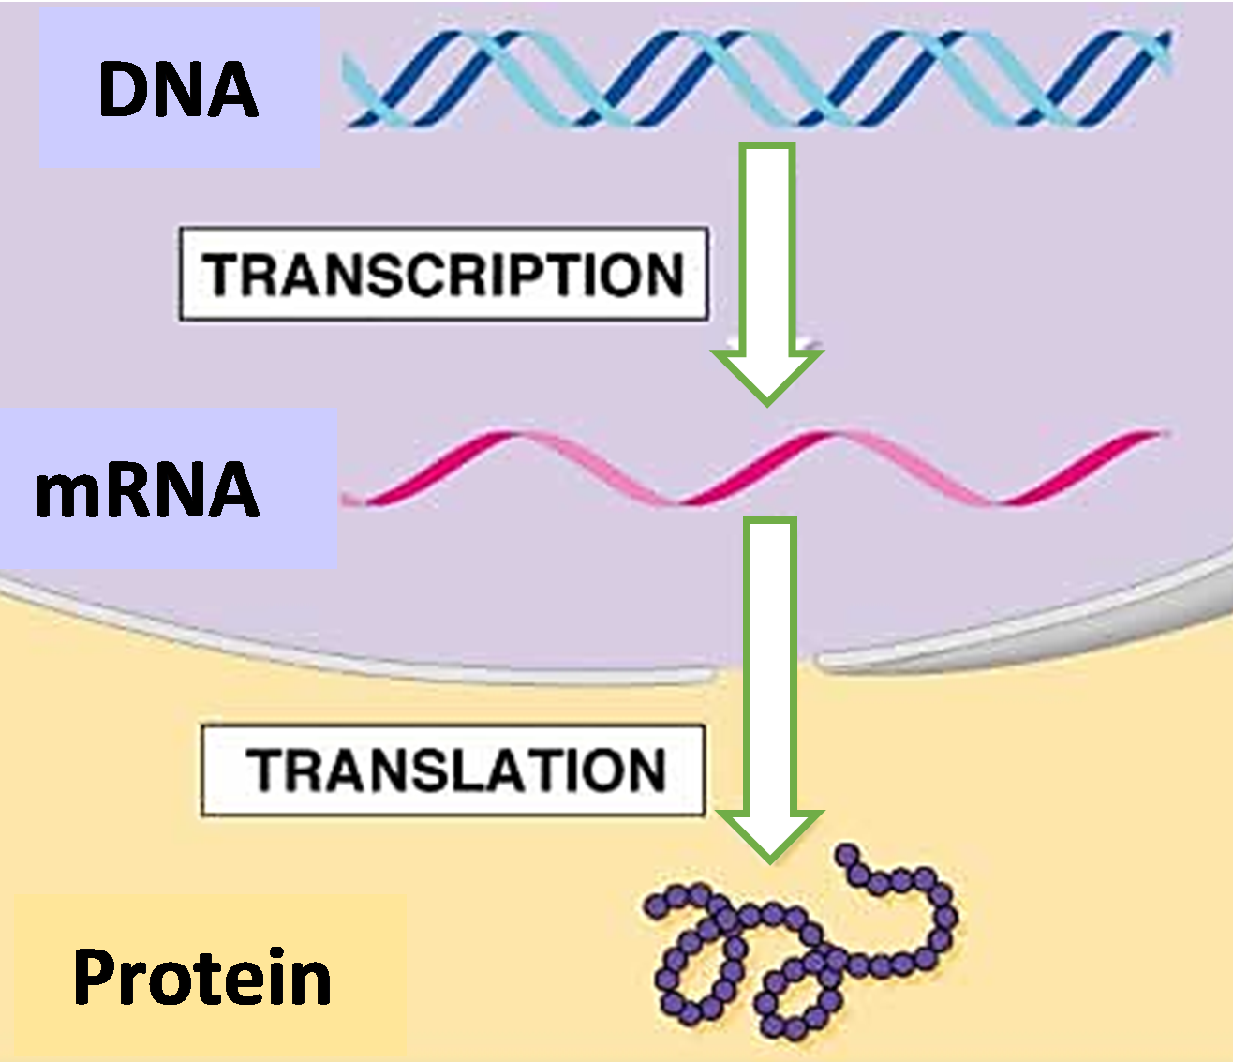
6a. Cells that are developing into red blood cells make hemoglobin, and other types of cells do not make hemoglobin. Which of the following statements correctly explains why?
- Cells that are developing into red blood cells have hemoglobin genes, and other types of cells do not have hemoglobin genes.
- Other types of cells have hemoglobin genes, but transcription of hemoglobin genes only occurs in cells that are developing into red blood cells.

6b. Explain your reasoning.

7. Near the end of the differentiation of red blood cells, the nucleus, ribosomes and mitochondria are evicted from each developing red blood cell. Why is it useful for the eviction of these organelles to be postponed until near the end of the differentiation of red blood cells? (Hint: Think about how the hemoglobin is made during the differentiation of red blood cells.)

To understand how transcription of the hemoglobin gene is regulated, you need to know that each gene includes two parts. One part (A in the figure) regulates the rate of transcription of the gene. The other part (B) provides the information for making mRNA during transcription. When a transcription factor binds to the regulatory region of a gene (A), this recruits RNA
polymerase to begin transcription of the coding region of the gene (B).  8. Explain how a transcription factor can turn on the production of hemoglobin proteins. | 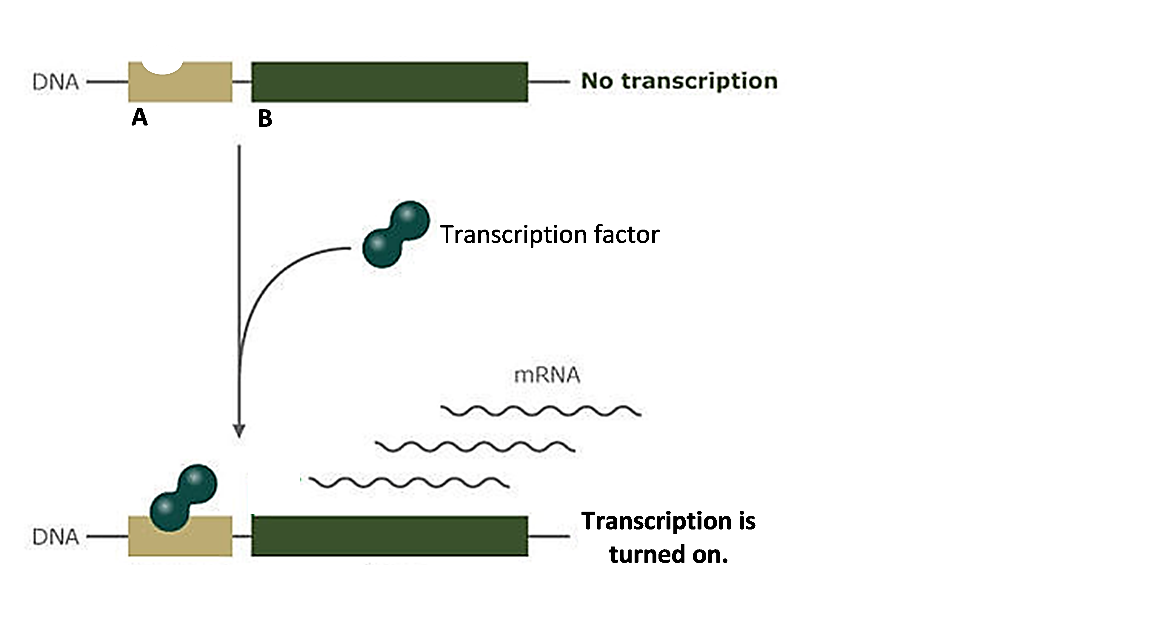

To understand another way that transcription factors influence whether or not transcription occurs, we need to review the structure of chromosomes. Each chromosome contains a very long molecule of DNA, which is wound around histone proteins. The figure below shows that the DNA of a gene plus histone proteins can take two different forms.
- On the left, the DNA plus histones in the region of a gene are bunched together. As a result, RNA polymerase cannot reach the DNA of the gene, so there is no transcription.
- On the right, acetyl groups have been added to the histones, so the DNA plus histones are more spread out. This allows RNA polymerase to reach the DNA and begin transcription of the gene.
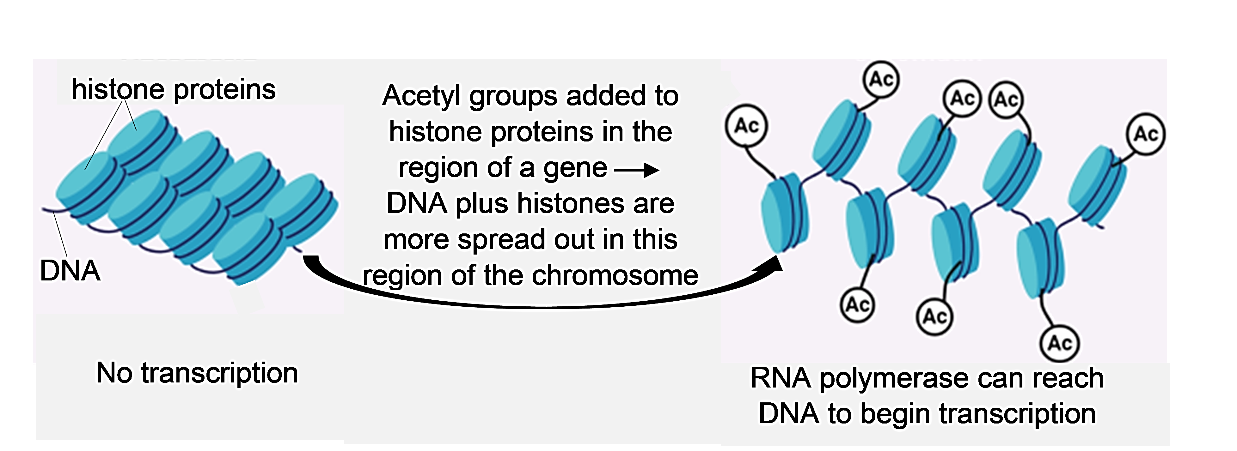

9. During differentiation of red blood cells, a transcription factor stimulates addition of acetyl groups to the histones of the hemoglobin gene. How does this help to start the production of hemoglobin proteins?

In summary, a transcription factor increases the rate of transcription of the hemoglobin gene by:
- helping to recruit RNA polymerase to the gene
- changing the local structure of the chromosome so RNA polymerase can reach the DNA of the gene.
This results in production of hemoglobin, a key step in making red blood cells.

By Dr. Ingrid Waldron, Dept Biology, Univ Pennsylvania, © 2024. This Student Handout and Teacher Notes (with learning goals, instructional suggestions, and background biology) are available at https://serendipstudio.org/exchange/bioactivities/RedBloodCells.

